Python with dictionary & Tuple 

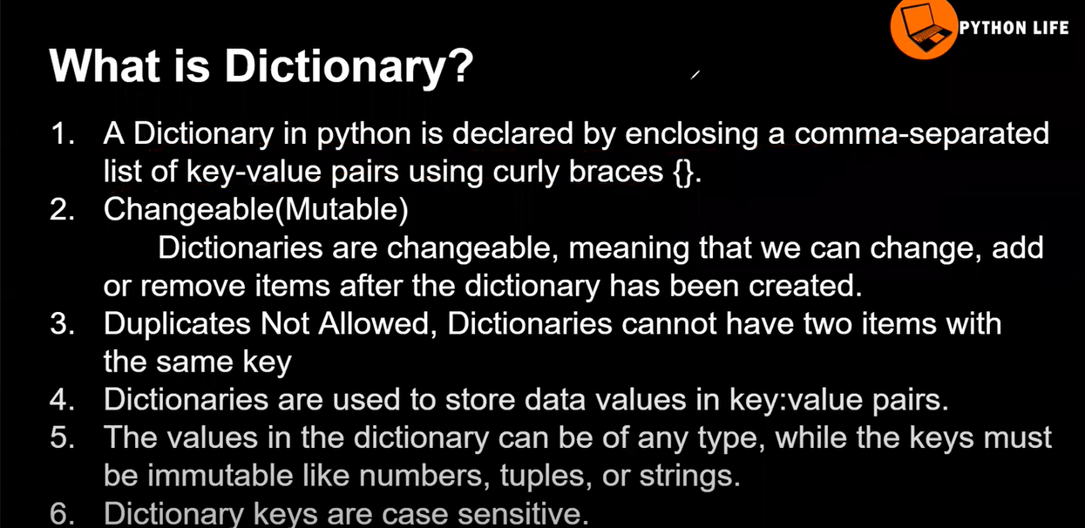
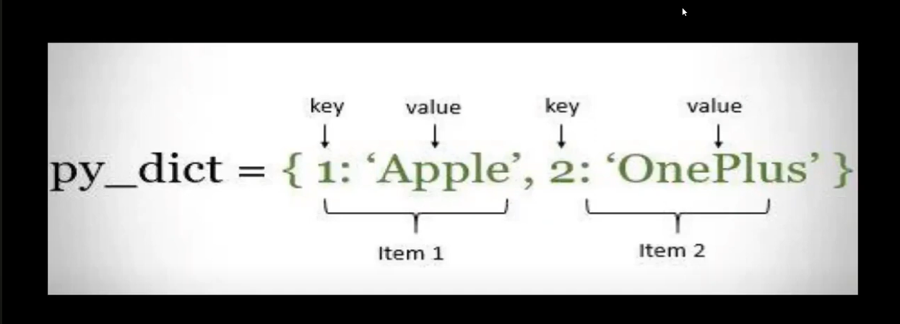
in that we cannot access the index here key is acting as index
we can change the vluse based on key bit key is immutable we cannot change key but we can change the value in that
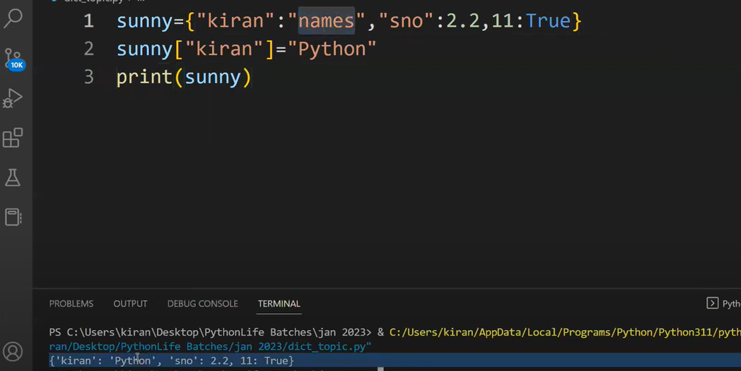
Dictionary method in python
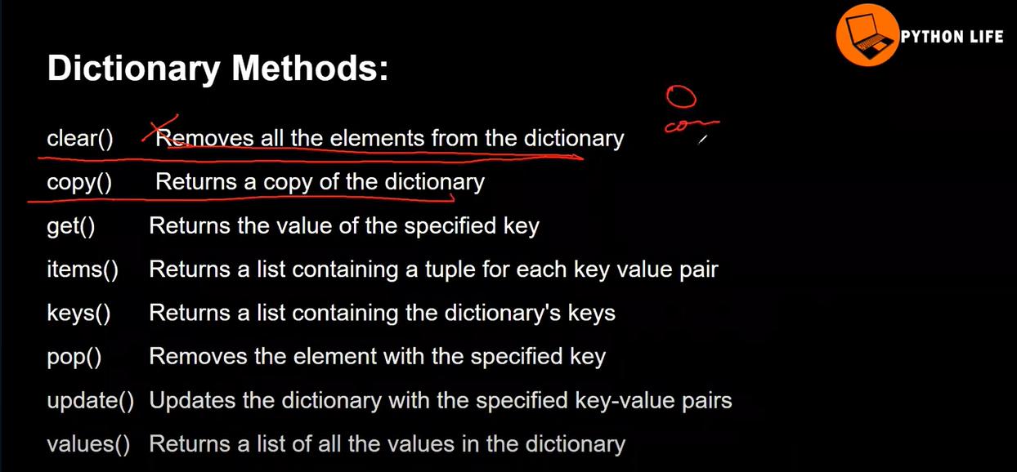
Get method using the key to fetch the specified value?
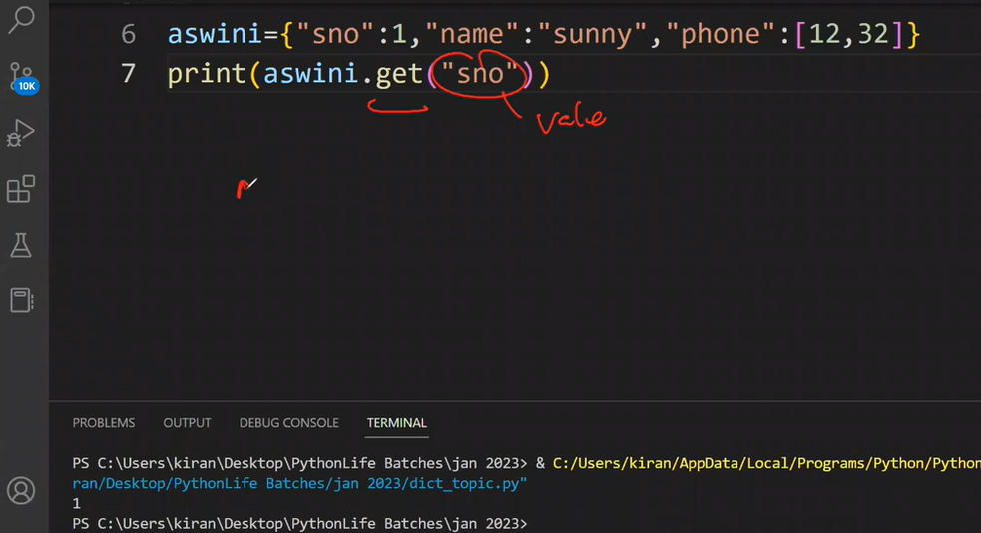
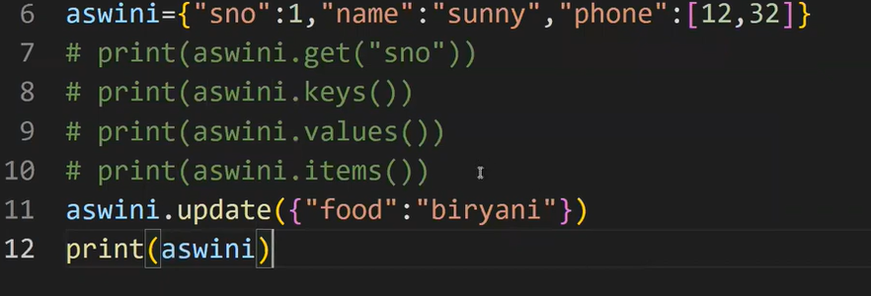
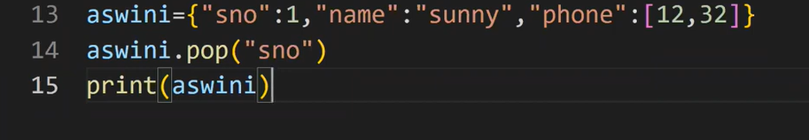
while converting into list only values are appears
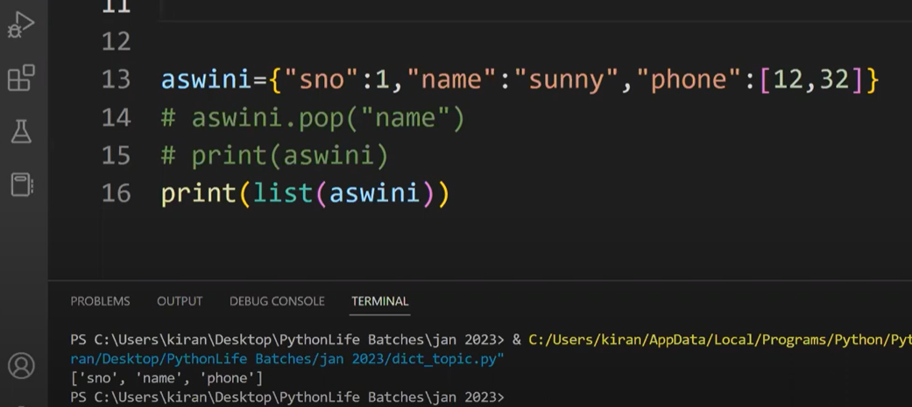
if iam using for loop in dict only key is reflected
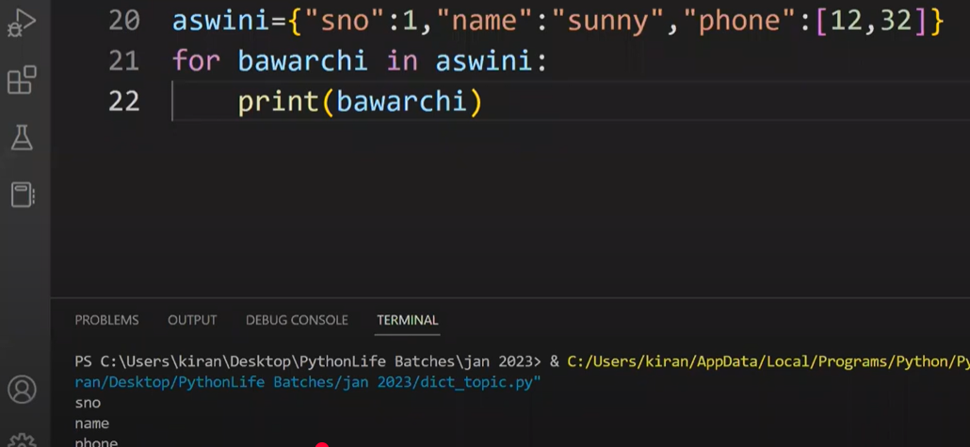
if I use item method it has converted in each key value into tuple so we can pass two argument for that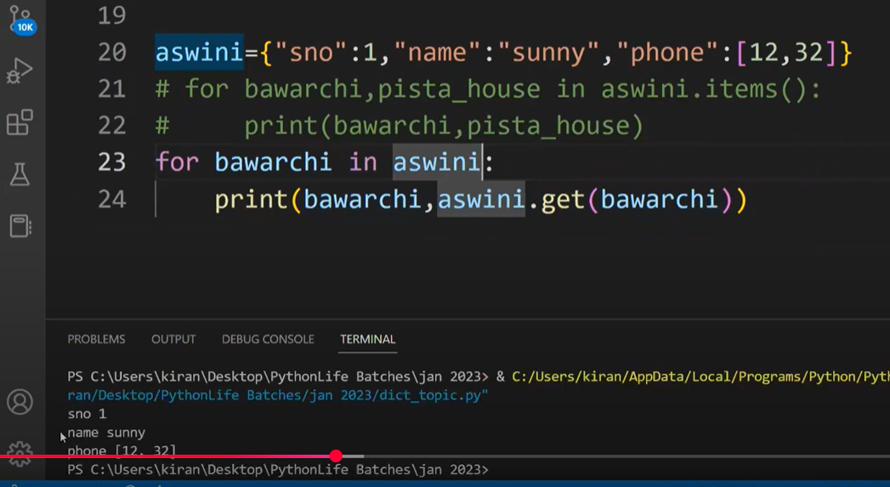
Nested dict
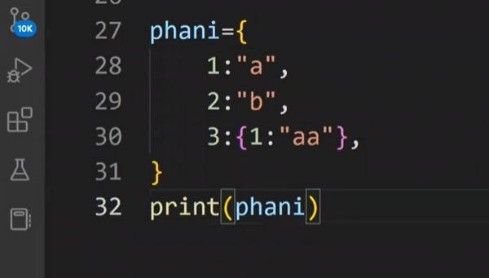
we can access the aa value int that 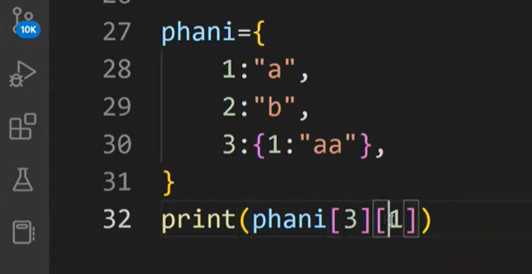
Tuple

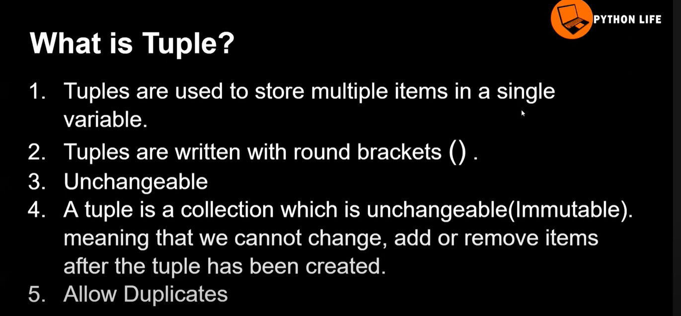
syntax for the Tuple
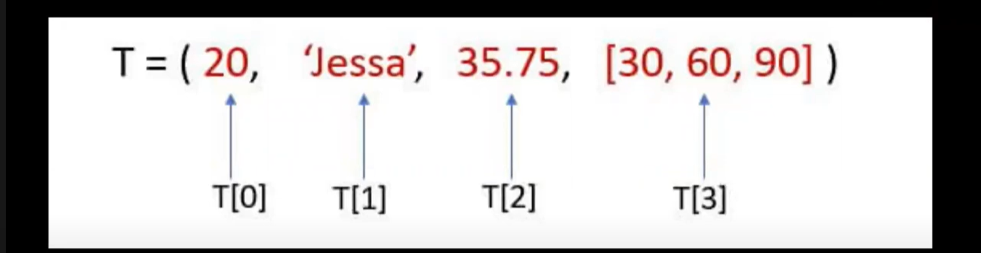

we can access the element but we cannot modified the values.
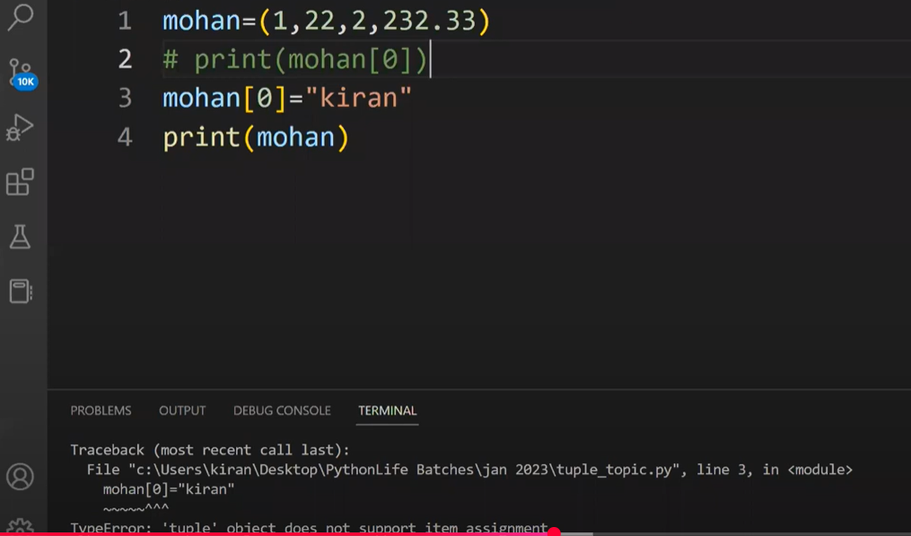
we can use built in function in python not for tuple method
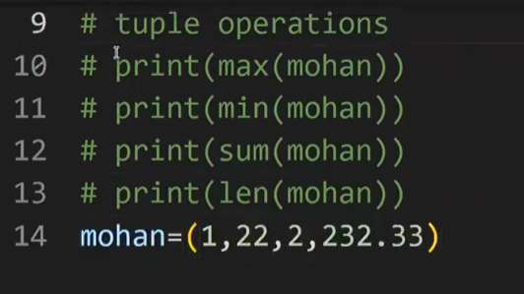
if you want modified the tuple first we can covert into tuple and we can use it
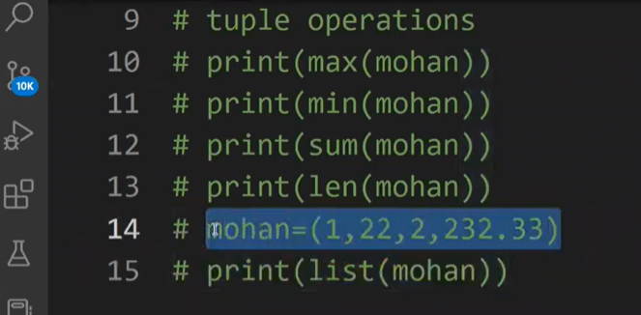
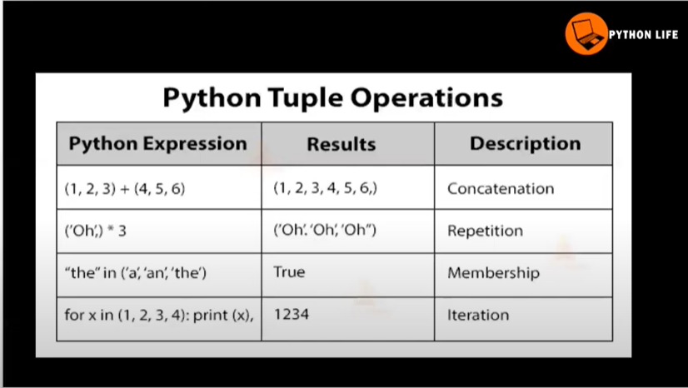
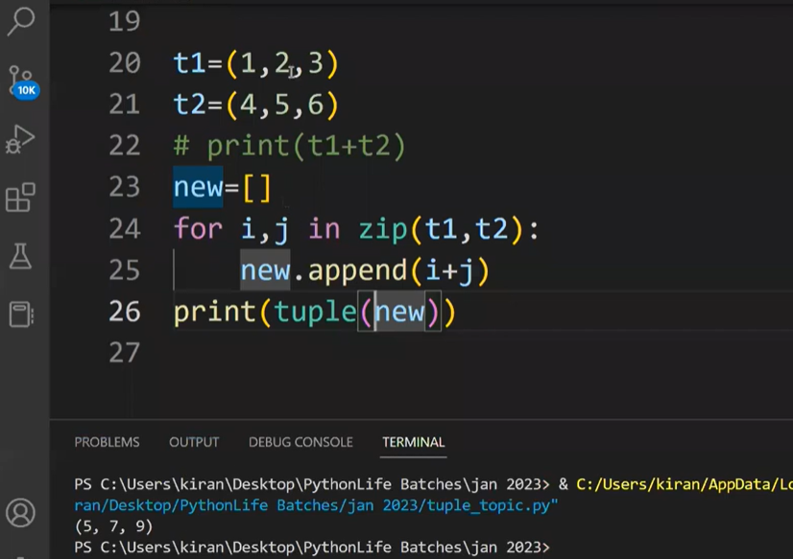
Membership operator is IN, Not in

Identity operator having IS, IS NOT
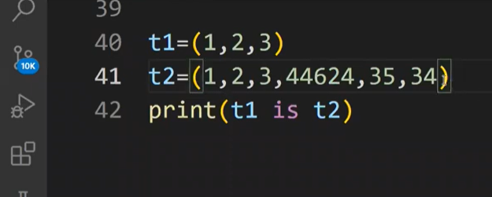
All datatype and functions using simple program “ATM program”
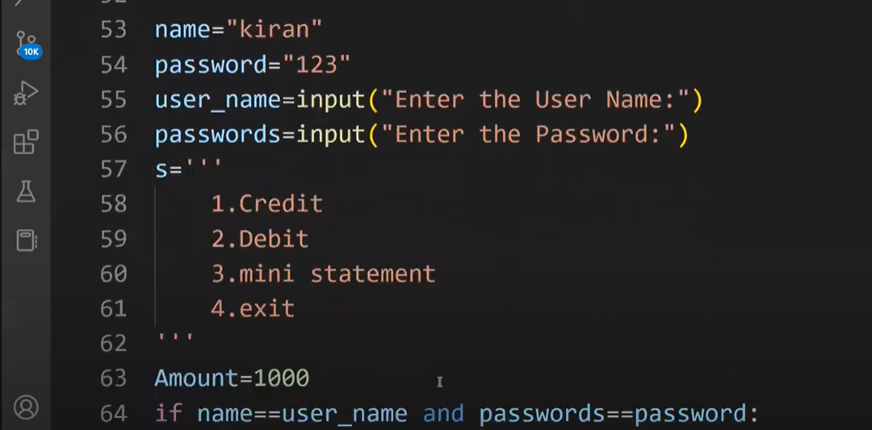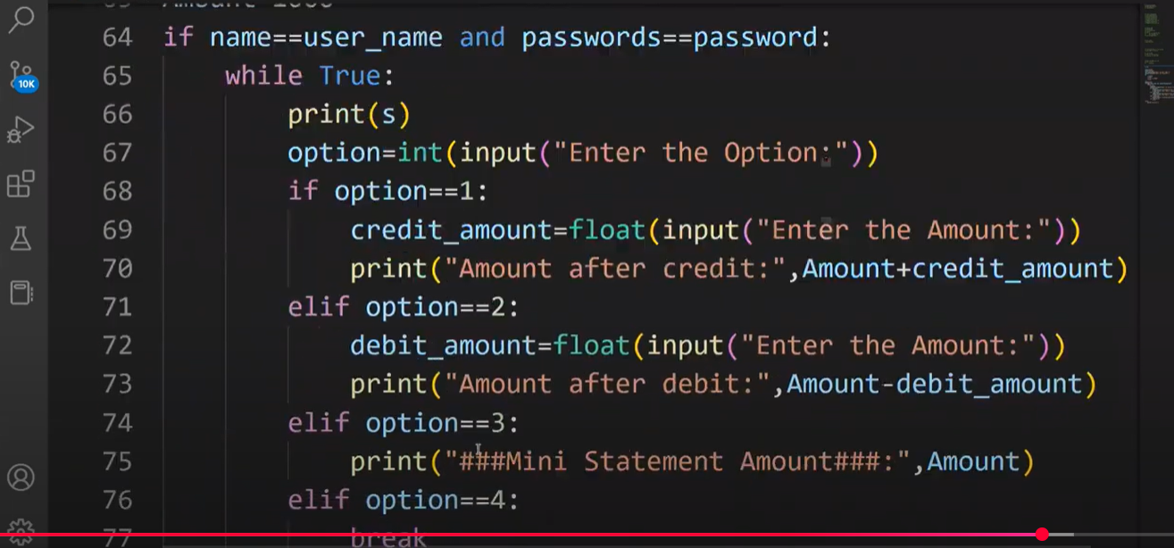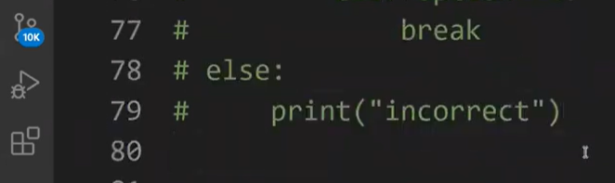
Simllar ATM program # ATM program

user ="karthik"
password="#gkv@upi"

B= '''
1.CREDIT
2.Debit
3.Ministatement
4.Exit
'''

user_name =input("Enter the Username :")
Passwords =input("Enter the Password :")

Amount =1000

if user_name==user and Passwords==password:
while True:
print(B)
option=int(input("Enete the option :"))
if option==1 :
Credit_amount=int(input("please enter the Amount:"))
print("Total credit amount is :",Amount+Credit_amount)
elif option==2:
Debit_amount=int(input("please enter the Amount:"))
print("Total credit amount is :",Amount+Debit_amount)
elif option==3 :

print("****Total amount is**** :",Amount)
else:
break
else:
print("User_name and password is incorrect please try again")

